Title: Do Swing States Vote for Democrats and Republicans Equally at the Local Level? An Analysis.

Subtitle: TBD

Swing states sometimes elect the president by mere thousands of votes out of millions. Does that tend to happen at the county level frequently?

**Introduction**

Swing states – states where the two major political parties enjoy roughly equal levels of support among voters -- are crucial in determining the ultimate winner of American presidential races. Since most states give all of their electoral votes to a single party, sometimes only a few thousand votes in a swing state can determine the winner of the entire national presidential election.

While overall, both Democrats and Republicans have equal support among voters in swing states, I want to understand if this dynamic extends to more local politics. In other words, I want to understand: **do swing state voters support Democrats and Republicans at fairly equal rates within each county, or is the support only equal at the state level?**

**Methodology**

I looked at 11 swing states – Colorado, Florida, Iowa, Michigan, Minnesota, New Hampshire, North Carolina, Ohio, Pennsylvania, Virginia, and Wisconsin, and calculated various statistics based on the 2018 midterm general election, held on November 6, 2018, using data from openelections.net<link>, which seeks to “create the first free, comprehensive, standardized, linked set of election data for the United States”.

**Caveats and Limitations**

I chose to limit myself to the 2018 midterm elections due to lack of time.

Instead of looking at individual races, most of my analysis centers on the difference in votes for Democrats and Republicans overall within each county rather than for a particular candidate.

When I do look at individual races, for the sake of simplicity and ease of calculation:

* I excluded races where a non-Democrat or Republican was a major contender.
* When I calculated the winner of a race, I simply looked at which party won the most votes in each county.
  + Note that “races won” is not reflective of actual candidates elected – most of the races I analyzed were actually held for state-wide positions and therefore simulate the winner of the race had it been for a county-level office.
* I made these choices to simulate which party would hold more power within the county rather than to reflect the realities of which party holds power within the state.

**Summary Statistics**

Voters cast **928 million total votes** combined in all of the swing states I analyzed. On average, voters cast **84 million** votes in each state. However, the votes cast in each state varied from **7 million** votes in New Hampshire to **200 million votes** in Florida.

Because the number of votes cast in each state varies so much, and many of them were cast for candidates that did not belong to a major political party, I focus my analysis on the margin.

**Margin**

The margin is the percentage of votes cast for Democrats or Republicans that the party won by. For example, the margin for all elections in Alamosa County, Colorado was 5%. That means that one party got 5% more votes than the other (in this case, Democrats got 5% more votes than Republicans).

We can think of a close margin as a margin of 10% or less, and a very close margin as a margin of 2% or less.

Swing states sometimes elect the president by mere thousands of votes out of millions. **Are races close at the county level?**

**First of all, which party tended to win races?**

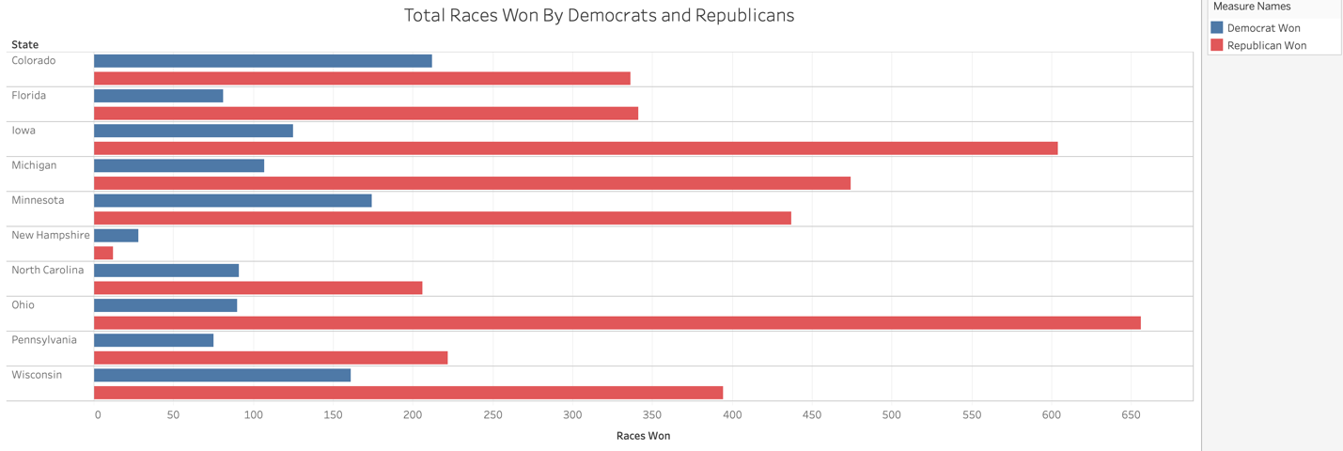

In all states except New Hampshire, Republicans won most of the elections held in the 2018 midterms. This means that Republicans likely hold most of the power within counties.

Note: “races won” is not reflective of actual candidates elected. Most of the races I analyzed were actually held for state-wide positions. This gives us an idea of what would have happened if the race had been held for a county-level office.

**Okay, but which party received more votes?**

This table shows the difference in total votes for Democrats and Republicans. If the difference was negative, Republicans got more votes, and if it was positive, Democrats received more votes.

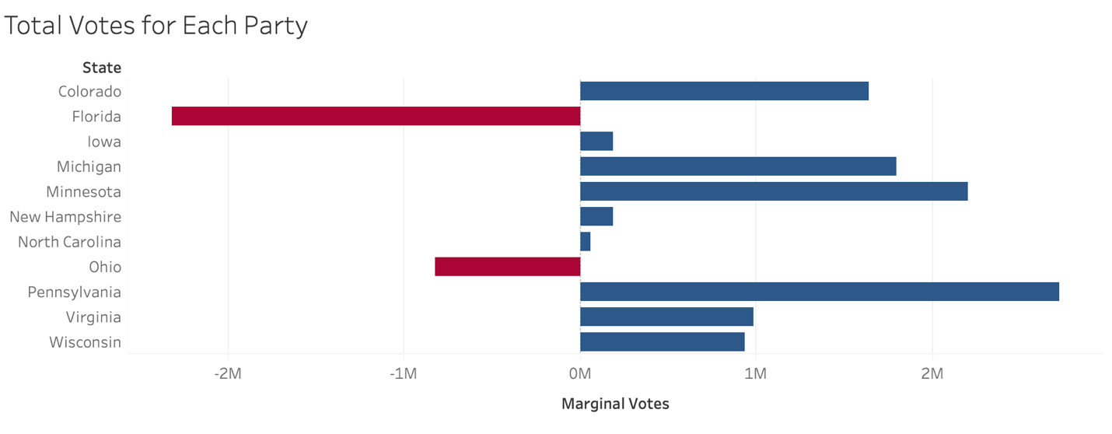

Interesting. In each state, Democrats received more total votes than Republicans, generally by at least 1 million. In a few states, Republicans and Democrats were fairly evenly matched – in Iowa and New Hampshire, the difference was only 185,000, and in North Carolina it was only 60,000. This stands in contrast to the fact that Democrats lost most of the races within counties, suggesting that certain counties hold most of the Democrats.

**How does having a city in the county affect the vote?**

There’s a common narrative in American political discourse that people in cities vote for Democrats, and everywhere else people vote for Republicans. Is that true?

In order to answer this question, I set up a chi-square test of independence to see if having a city in a county was related to whether the majority of a county’s votes went to Democrats. I also ran a Fisher’s R test, because the total number of counties I analyzed was fairly small and chi-square tests are less accurate on small sample sizes. I defined a big city as a city that had a population of over 100,000 in the 2010 census.

I calculated values for the following table, and used it to run the tests of independence:

|  |  |  |
| --- | --- | --- |
|  | County contained a big city | County DID NOT contain a big city |
| Majority of votes went to Democrats | 54 | 220 |
| Majority of votes went to Republicans | 13 | 644 |

The p-value for both the chi-square test and Fisher’s R was less than 2.2 x 10^16, or just about 0, which means that whether a county contains a city and whether the votes went to Democrats or Republicans are definitely related. However, it does not tell us whether cities voted for Democrats or Republicans in general.

How can we find that out? It’s actually a fairly simple thing to eyeball. I plotted the margin between votes for Democrats and Republicans in each county on a graph, with a negative margin for Republicans and a positive margin for Democrats.

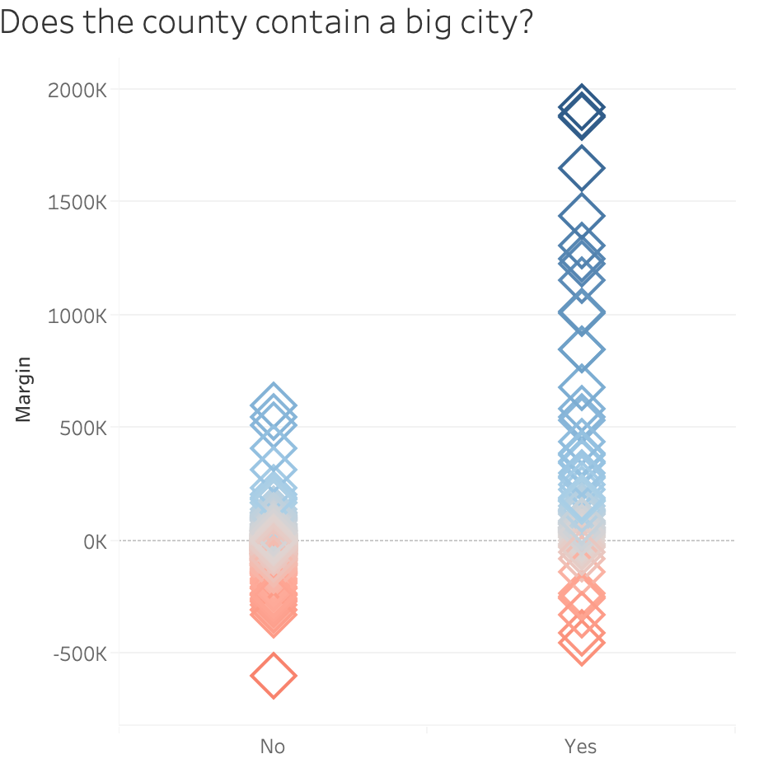

Looking at this graph, it’s pretty clear that Democrats got the most votes within counties that contained cities, because most margins in counties that contained cities are positive, and very positive, suggesting that most of the time Democrats won by a lot in counties with cities.

Though Democrats generally won in cities, did they win overwhelmingly? **In other words, were small margins less likely to happen in counties with big cities than in counties without them?** This is another way to help us determine if big cities have similar levels of support among Democrats and Republicans. Why? If they are no more likely to have close margins than counties without cities, and we find that most counties in swing states have close elections, then it would suggest that Democrats and Republicans are evenly matched in swing states, even in cities.

I ran a chi-square and Fisher’s R tests on the following tables:

|  |  |  |  |  |  |  |
| --- | --- | --- | --- | --- | --- | --- |
|  | County contained a big city | County DID NOT contain a big city |  |  | County contained a big city | County DID NOT contain a big city |
| Margin was greater than 10% | 54 | 721 |  | Margin was greater than 2% | 63 | 834 |
| Margin was less than or equal to 10% | 13 | 143 |  | Margin was less than or equal to 2% | 4 | 30 |

The p-values were well over 0.10 in all cases, ranging from 0.3 to 0.67. This tells us that counties with cities were no more likely to have big (or small) margins than counties that didn’t contain cities.

So far, we’ve answered:

* Who wins the most races? Republicans.
* Who gets the most votes? Democrats.
* Do cities affect which party get the most votes? Yes, and Democrats get the most votes within counties that contain cities.

**Do Democrats and Republicans generally receive similar percentages of the vote at the county level?**

But we still haven’t completely answered: **Do Democrats and Republicans generally receive similar percentages of the vote at the county level?** We partially answered that with our analysis of counties with cities, but we can do better.

We can think of a close margin as 10% or less, and a very close margin of 2% or less. Anything above 10% is not a close margin.

What was the average margin in each state? ***In other words, what was the average amount that a party won the votes in a given county by?***

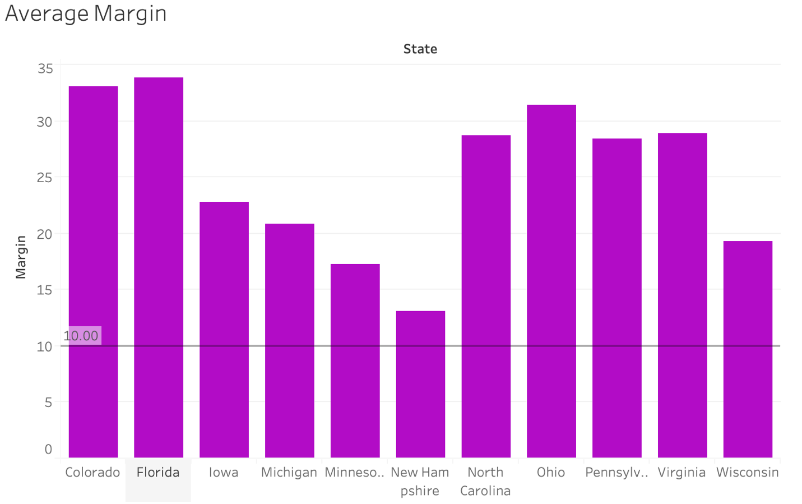

In general, parties won by over 10%. That means that most elections within the counties, even within swing states were not close, suggested that Democrats and Republicans are not evenly distributed geographically across swing states.

This is consistent with the finding that Democrats and Republicans are no more likely to have equal levels of support within counties that don’t contain big cities as counties that counties that do have big cities. It suggests that most counties prefer one party over another reasonably strongly.

**How often were the actual elections within each county close?**

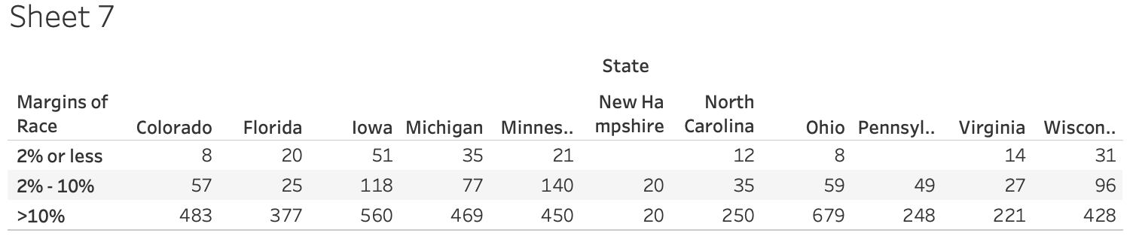

In general, the elections (races) were not close. However, in several states (Iowa, Minnesota, Wisconsin), about a quarter of the races were close or very close. In the case of New Hampshire, half of the races were close. While the number of close races in each race was not high, it was not insignificant. (In the future, it would be interesting to compare these numbers to non-swing states and in different years.)

**Was there a party split within close margins? As in, when the margin was small, did one party tend to win?**

This graph has a dot for each county in each state where the difference in **total** votes for Democrats and Republicans was 10% or less. The dot is red if Republicans received more votes, and the dot is blue if Democrats received more votes. 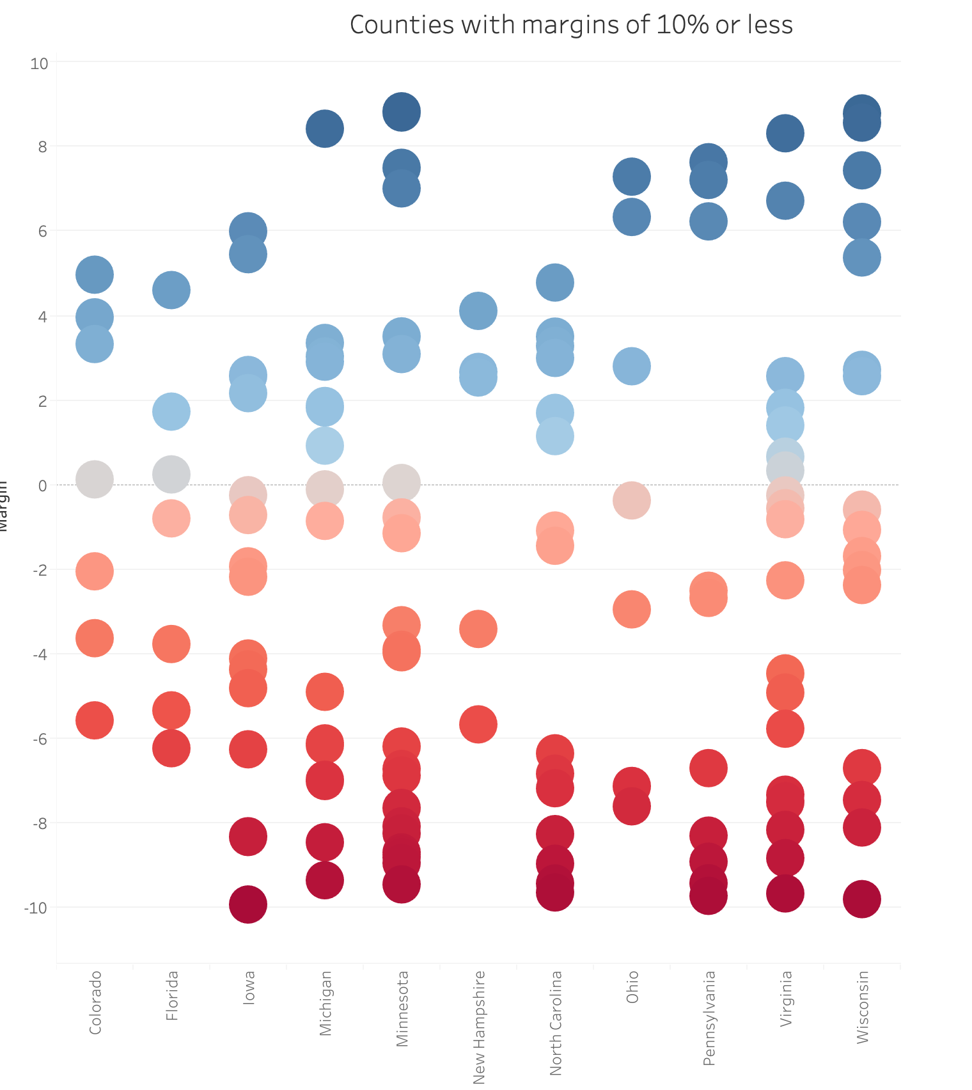

Looking at this graph, it seems like Republicans maybe won most of the close elections, but not conclusively. So we can’t really say whether mostly Democrats or Republicans tended to win close races.

If you want to see a map of margins within counties for each of the states, go here <link to Tableau map – make it so that they can adjust the margin to >10%, 2-10%, <2%>.

**Conclusions**

My main question in this analysis was:

*Do swing state voters support Democrats and Republicans at fairly equal rates within each county, or is the support only equal at the state level?*

We learned that:

* Republicans tended to win the most elections held in counties, but Democrats won the most votes overall.
* Counties with big cities voted overwhelmingly for Democrats.
* Most counties, in most states, voted for one party over the other by a large margin.
* Close races happened about a quarter (25%) of the time within each swing state.
* When the margin was close, neither party seemed to win consistently.

Taken together, this confirms a well-known narrative of Democrats having more support in areas with large cities and Republicans having more support in less urban areas.

So the answer to my question is: **in general, Democrats and Republicans only enjoy near-equal levels of support at the state level, not the local level.**